Assignment 3: Fun with Process and Memory
2.39:
Three child process are created upon execution.
2.40:
In round-robin scheduling, each process is assigned a time interval, during which it is allowed to run. If a process occurs twice in a list then with each process it will get two turns. One reason for allowing this would be to implement a priority system.
2.45:
Job → running times, priority
A → 10,3; B → 6,5; C → 2,2; D → 4,1; E → 8,4
For each of the following scheduling algorithms, determine the mean process turnaround time. Ignore process switching overhead.
a). Round Robin:
b). Priority Scheduling:
Average turnaround = (6+14+25+27+31) / 5 = 20.6 minutes
c). First-come, first served (run in order 10,6,2,4,8)
Average turnaround = (11+17+19+23+31) / 5 = 20.2 minutes
d). Shortest job first:
Average turnaround = (2+6+12+20+31) / 5 = 14.2 minutes
3.7:
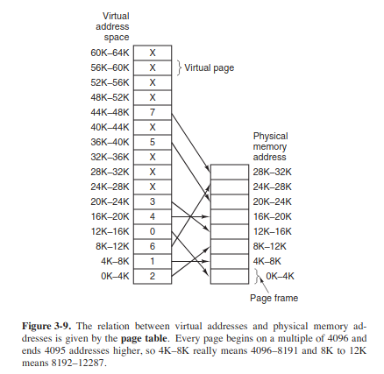

3.13:
Formula for effective instruction time = (k + n) / k
3.16:
Given the following data about a virtual memory system:
a). The TLB can hold 1024 entries and can be accessed in 1 clock cycle (1 nsec)
b). A page table entry can be found in 100 clock cycles or 100 nsec
c). The average page replacement time is 6 msec
If page references are handled by the TLB 99% of the time, and only 0.01% lead to a page fault, what is the effective address-translation time?
Answer:
Address-translation time = P(TLB) X Time(TLB) + P(no page fault) X Time(page table) + P(page fault) X Time(replacement)
P(TLB) = 0.99; T(TLB) = 1nsec; P(no page fault) = 0.0001; T(page table) = 1 msec = 6000000;
P(page fault) = .00999; T(page table) = 100
= (.99 X 1) + (.0001 X 6000000) + (.0099 X 100) = 601.98 nsec
3.29:
Consider the page sequence of the figure below:
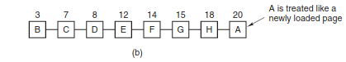

Suppose that the R bits for the pages B through A are 11011011, respectively. Which pages will second chance remove?
Answer:
The second chance algorithm will remove page D

